Project Design Phase-II

Technology Stack (Architecture & Stack)

Technical Architecture:

The Deliverable shall include the architectural diagram as below and the information as per the table1 & table 2.

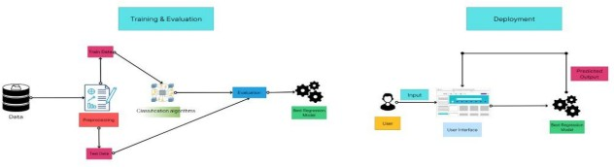

Table-1 : Components & Technologies:

|  |  |  |
| --- | --- | --- |
| **S.No** | **Component Description** | **Technology** |
| 1. | User Interface How user interacts with application e.g. Web UI, Mobile App,  Chatbot etc. | Flask API |
| 2. | Application Logic-1 Load the dataset | Jpeg Images |
| 3. | Application Logic-2 Classification | Random Forest Classifier |
| 4. | Application Logic-3 Evaluation | Python |
| 5. | Machine Learning Model Purpose of Machine Learning Model | Object Recognition Model |